Irrigation Problem

Prepared by: Patrick AOUN | 201710226

# Answer the following questions for the irrigation problem

# Fill the following table with the duration of irrigation for every case

|  |  |  |  |  |
| --- | --- | --- | --- | --- |
|  | Centroid | lom (max of maximum) | Mom (mean of maximum) | som (min of maximum) |
| Humidity = 1  Temperature = 1 | 30 | 30 | 30 | 30 |
| Humidity = 1  Temperature = 45 | 57.333 | 70 | 60 | 50 |
| Humidity = 10  Temperature = 35 | 39.647 | 40 | 30 | 20 |
| Humidity = 25  Temperature = 10 | 8.444 | 10 | 6.5 | 0 |
| Humidity = 30  Temperature = 1 | 7.777 | 10 | 5 | 0 |
| Humidity = 30  Temperature = 35 | 30 | 30 | 30 | 30 |

# Analyse vertically and horizontally the results obtained in the previous table, i.e. answer questions such as

## For humidity =1 and temperature = 45, do we always get the maximum duration of 70 minutes (which one might expect for this kind of input)? Explain.

No we don’t always get the duration of 70 because while using **lom,** we will always the get max of maximum and in this case it is the highest abscise which is equal to 70

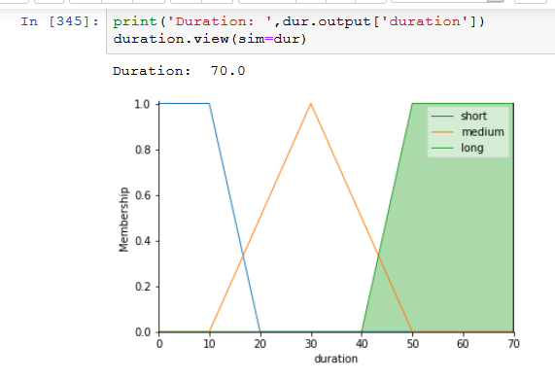

For **som**, it is 50 and **mom** it is 60 (it is like the average of lom and som)

## Do some methods give same results for several inputs? Explain

Yes, in the table, for example, when humidity is 1 and temperature is 1, we get for both centroid and mom we get a duration of 30.

In my opinion, I think this is due of the inputs and how the rules will work; we will get a certain graph where we can get the same duration for different methods. Maybe the points of maximum will be the same for both methods (In French points confondus). 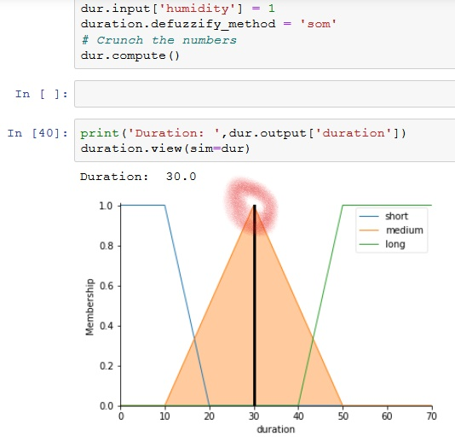

Figure : Using 'som’

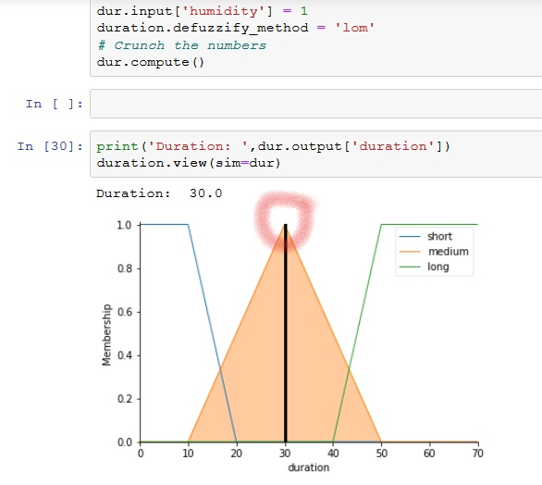

Figure : Using 'lom'

## Is there a ‘best’ defuzzification method? Explain

In my opinion, the best defuzzification method might be the **centroid** method, because it relies on the center of gravity of the membership function to calculate the crisp value of the output/consequence variable.

In addition, in the table, for example, for humidity=25 and temperature=10, using the **som** method will give us a 0 as duration, same as humidity=30 and temperature=1.

So, for humidity=10 and temperature=35, for **som**, **lom** and **mom** we have straight values like 40 30 20 but for **centroid** it is equal to 39.64 which might be an average value for the whole graph. More like the center of gravity of the graph.